**User manual and Project demonstration**

This manual is designed to guide users through the installation, deployment, and usage of the NBA Data Retrieval System.

1. System Deployment/Installation:

Prerequisites:

* Python 3.6 or later installed.
* pip package manager installed.

Steps:

1. Clone the project repository from GitHub Link.
2. Navigate to the project directory using the command line.
3. Install the required dependencies using the following command:
4. Copy code
5. pip install -r requirements.txt
6. Launch the application by running the main script:
7. css
8. Copy code
9. python main.py

2. Technical Specifications:

* Programming Language: Python 3.6 or later
* GUI Framework: PyQt5
* API Packages: nba-api, py-ball
* External Dependencies: requests, PyQt5

3. Main Features:

The NBA Data Retrieval System allows users to:

* View team information
* View player details

4. Main Scenario Walkthrough:

Upon launching the application, the user is presented with a clean and intuitive interface.

Click on the "NBA DATA" button to view details about NBA teams and players.

5. Additional Scenarios:

Scenario 1: View team information and player details

Click on the " NBA DATA " button.

Scenario 2: Error Handling

Attempt to retrieve information without an internet connection.

Observe the system's error handling mechanism displaying a user-friendly message.

(I did the Project on lab’s computer so I couldn’t disconnect the internet.

6. Screenshots and Figures:

* Figure 1: Main Interface
* Figure 2: Team Information Scenario

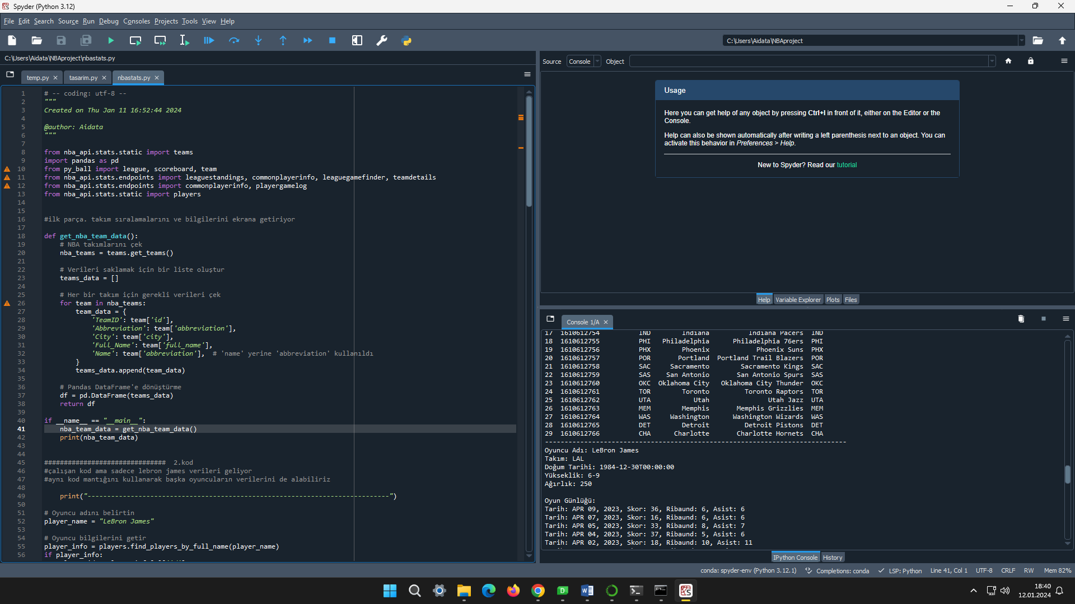



* Figure 3: Player Information Scenario

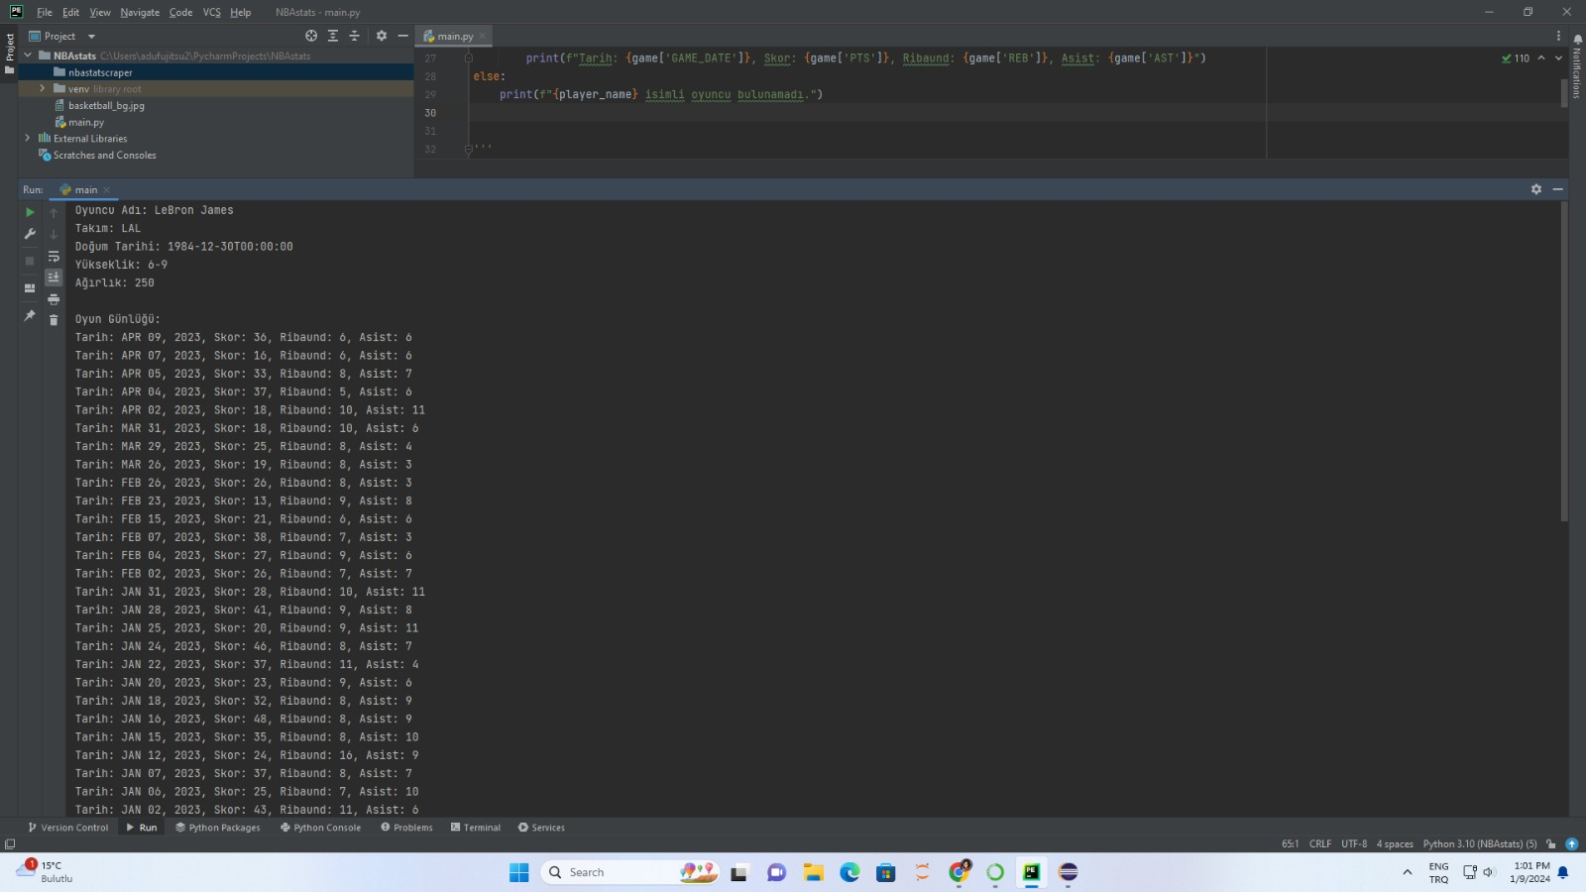

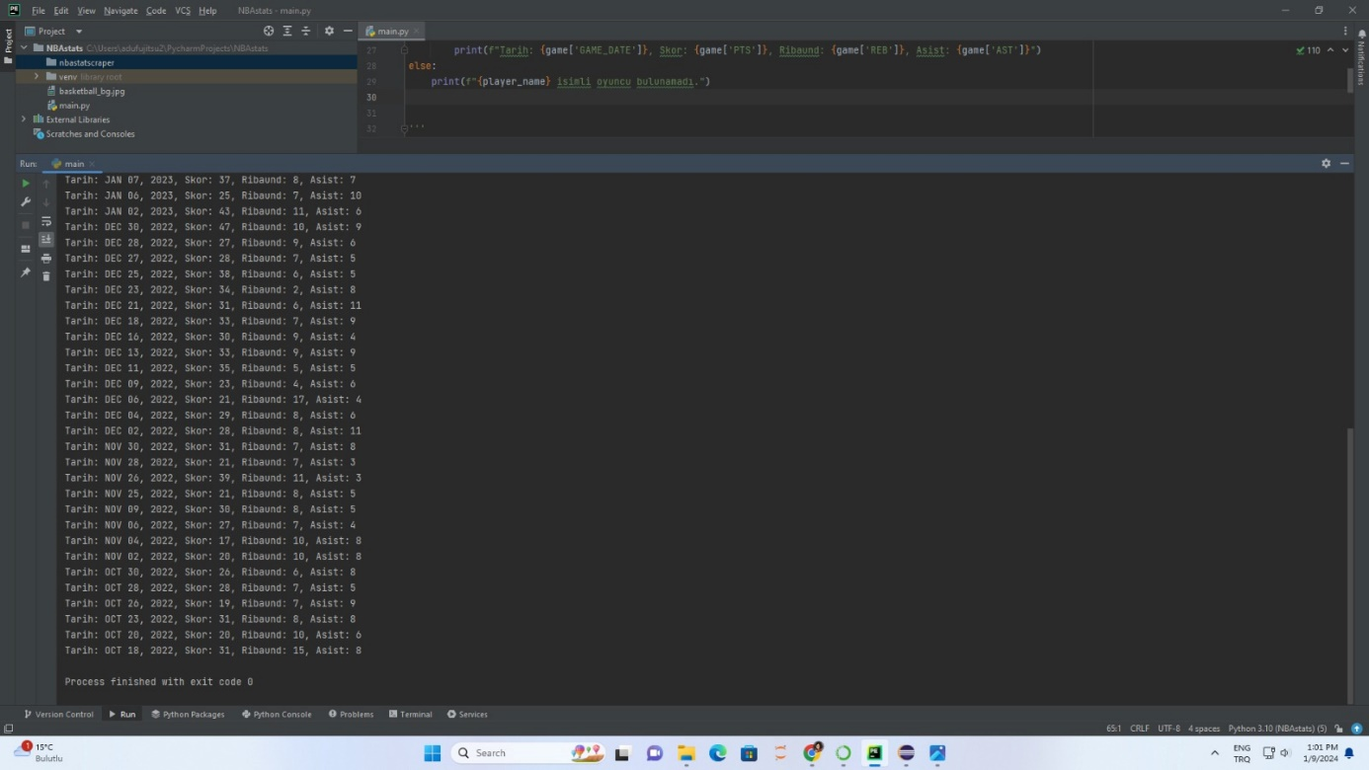

7. Conclusion:

The NBA Data Retrieval System simplifies the process of accessing NBA team and player data. By following the steps outlined in this user manual, users can effortlessly explore various functionalities. The clean interface and error handling mechanisms enhance the overall user experience.

Conclusion:

The NBA Data Retrieval System has successfully achieved its primary objectives, providing users with a user-friendly interface to access NBA team and player data effortlessly. The implementation of features like team information retrieval and player details display demonstrates the system's capability to meet the core requirements.

Moving forward, the identified potential user stories present exciting opportunities for further system refinement and expansion. Considering features such as multi-team comparison, favorite teams and players, historical data retrieval, advanced search and filtering, and data export options would enhance the overall utility of the system.

User feedback and evolving requirements will play a crucial role in shaping the system's roadmap. Regular updates and releases should be planned to address user needs and maintain the system's relevance in a dynamic environment.

In conclusion, the current version of the NBA Data Retrieval System serves as a solid foundation for future enhancements. By incorporating additional functionalities based on user stories and feedback, the system can continue to evolve, providing an even more comprehensive and valuable tool for NBA enthusiasts and analysts alike. The development team remains committed to delivering an exceptional user experience and staying responsive to the evolving landscape of NBA data analysis.



|  |  |  |  |  |
| --- | --- | --- | --- | --- |
| Name | Surname | Student No | Github | E-Mail |
| Neslihan | Çatak | 191805006 | github.com/NeslihanCatak | [191805006@stu.adu.edu.tr](mailto:191805006@stu.adu.edu.tr) |